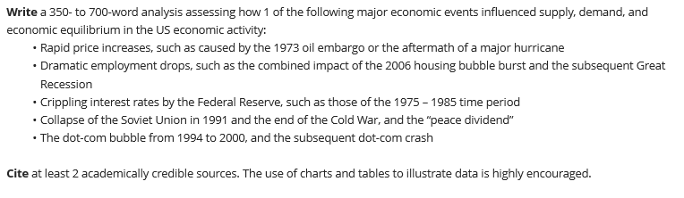
Instructions:

If you need help finding article use following location

